**Document to run test cases**

**PreRequisites :**

Install jdk1.8 version ,Above maven 3.0.0 version,chrome browser in windows 10 machine

Checkout code from github url to local machine

**Steps to run automation**

Move to command prompt directory where code has taken checkout

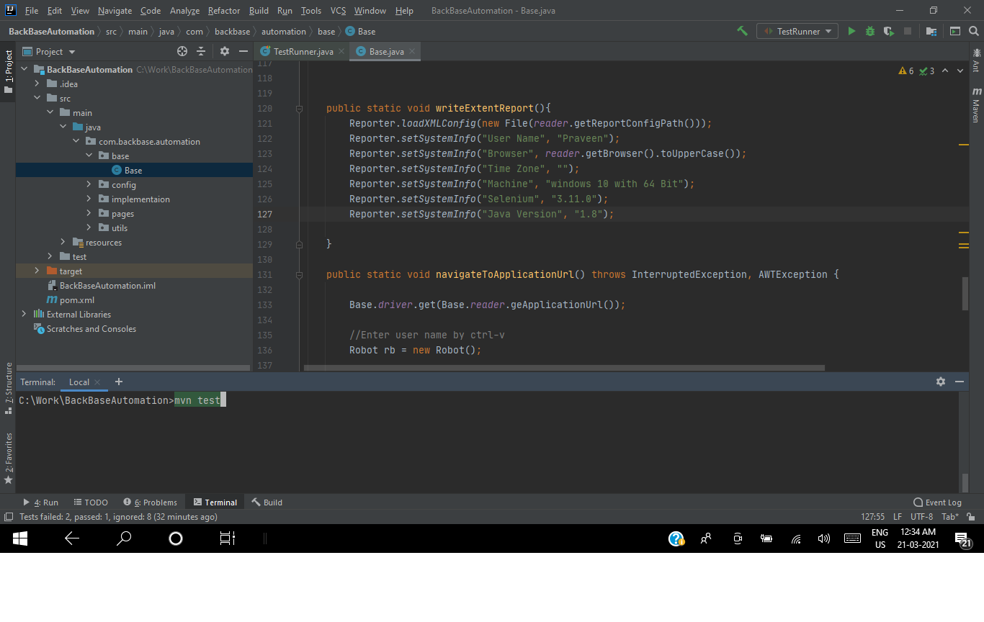

Run **mvn test** command as per above screenshot

**Note** :We can run the test cases from TestRunner.java class

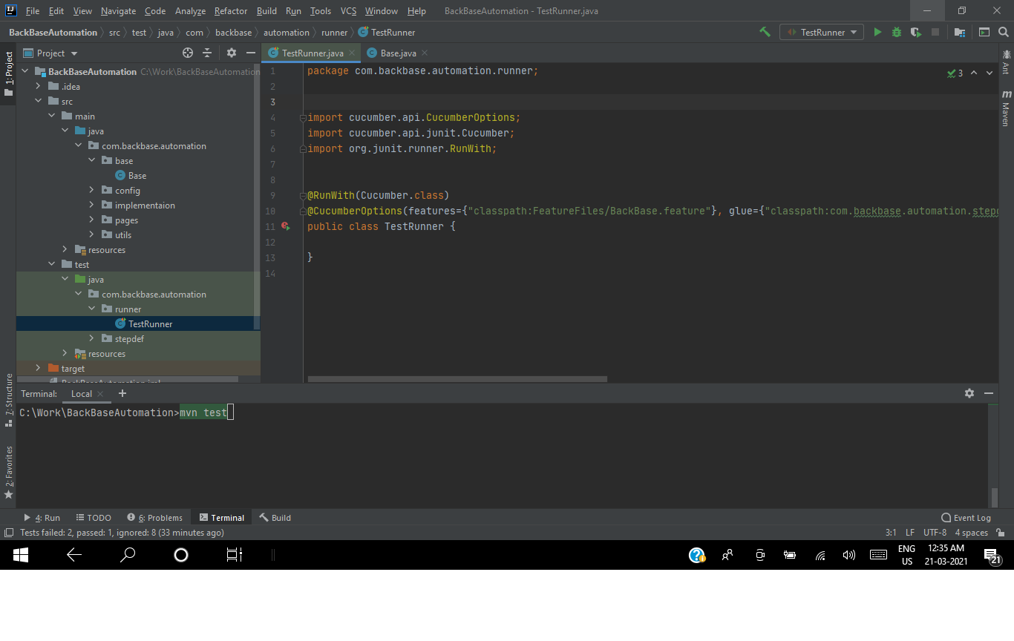

Once test case executed check extent report with name report.html in target/cucumber-report directory as per below screenshot

